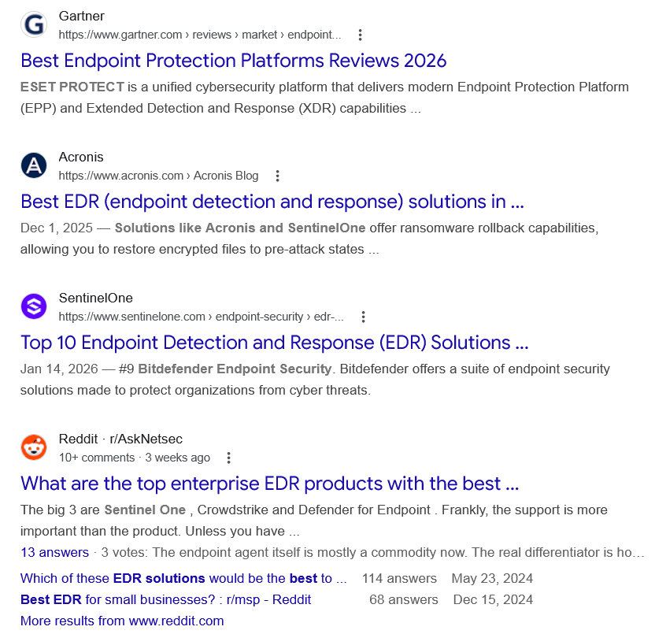
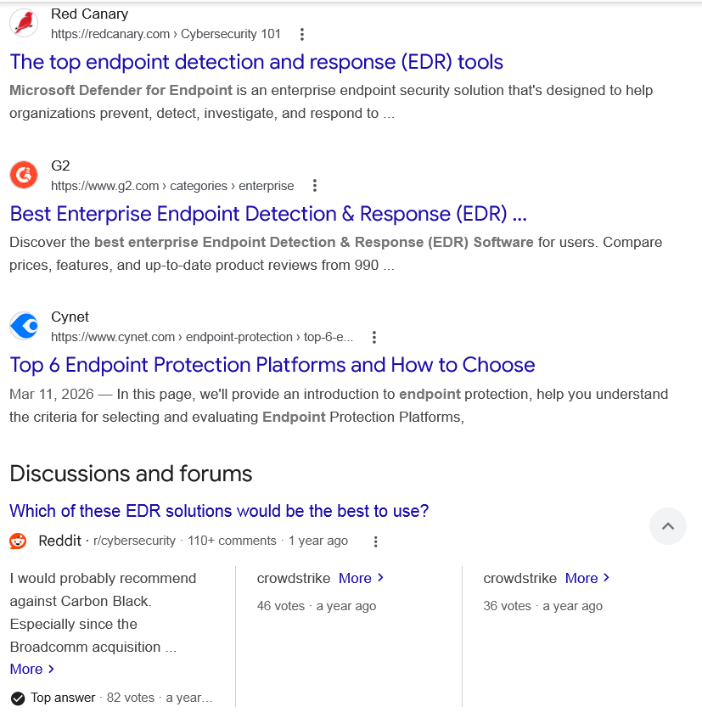
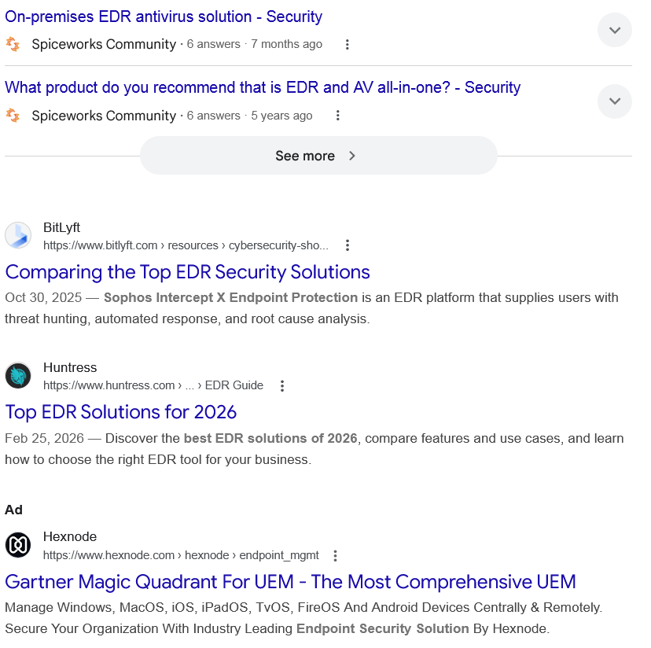
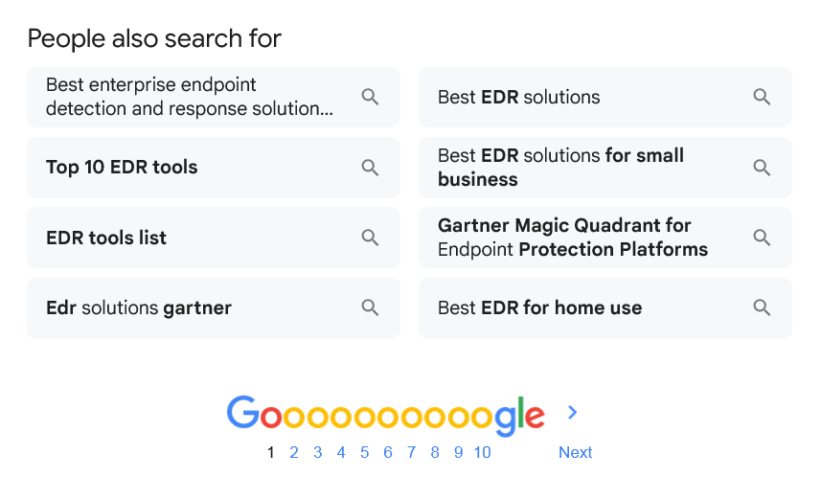

Web results

Best Endpoint Protection Platforms Reviews 2026

Gartner
https://www.gartner.com › reviews › market › endpoint...

Gartner
https://www.gartner.com › reviews › market › endpoint...
ESET PROTECT is a unified cybersecurity platform that delivers modern Endpoint Protection Platform (EPP) and Extended Detection and Response (XDR) capabilities ...

Best EDR (endpoint detection and response) solutions in ...

Acronis
https://www.acronis.com › Acronis Blog

Acronis
https://www.acronis.com › Acronis Blog
Dec 1, 2025 — Solutions like Acronis and SentinelOne offer ransomware rollback capabilities, allowing you to restore encrypted files to pre-attack states ...

Top 10 Endpoint Detection and Response (EDR) Solutions ...

SentinelOne
https://www.sentinelone.com › endpoint-security › edr-...

SentinelOne
https://www.sentinelone.com › endpoint-security › edr-...
Jan 14, 2026 — #9 Bitdefender Endpoint Sеcurity. Bitdefender offers a suite of endpoint security solutions made to protect organizations from cyber threats.

What are the top enterprise EDR products with the best ...

Reddit · r/AskNetsec
10+ comments · 3 weeks ago

Reddit · r/AskNetsec
10+ comments · 3 weeks ago
The big 3 are Sentinel One , Crowdstrike and Defender for Endpoint . Frankly, the support is more important than the product. Unless you have ...
13 answers · 3 votes: The endpoint agent itself is mostly a commodity now. The real differentiator is how fast a human ...
Which of these EDR solutions would be the best to ...
114 answers
May 23, 2024
Best EDR for small businesses? : r/msp - Reddit
68 answers
Dec 15, 2024
More results from www.reddit.com

The top endpoint detection and response (EDR) tools

Red Canary
https://redcanary.com › Cybersecurity 101

Red Canary
https://redcanary.com › Cybersecurity 101
Microsoft Defender for Endpoint is an enterprise endpoint security solution that's designed to help organizations prevent, detect, investigate, and respond to ...

Best Enterprise Endpoint Detection & Response (EDR) ...

G2
https://www.g2.com › categories › enterprise

G2
https://www.g2.com › categories › enterprise
Discover the best enterprise Endpoint Detection & Response (EDR) Software for users. Compare prices, features, and up-to-date product reviews from 990 ...

Top 6 Endpoint Protection Platforms and How to Choose

Cynet
https://www.cynet.com › endpoint-protection › top-6-e...

Cynet
https://www.cynet.com › endpoint-protection › top-6-e...
Mar 11, 2026 — In this page, we'll provide an introduction to endpoint protection, help you understand the criteria for selecting and evaluating Endpoint Protection Platforms,
Discussions and forums

Which of these EDR solutions would be the best to use?
Reddit ·
r/cybersecurity
· 110+ comments
· 1 year ago

Which of these EDR solutions would be the best to use?
Reddit ·
r/cybersecurity
· 110+ comments
· 1 year ago
I would probably recommend against Carbon Black. Especially since the Broadcomm acquisition ... More
Top answer · 82 votes · a year ago
crowdstrike More
46 votes · a year ago
crowdstrike More
36 votes · a year ago

On-premises EDR antivirus solution - Security
Spiceworks Community ·
6 answers
· 7 months ago

On-premises EDR antivirus solution - Security
Spiceworks Community ·
6 answers
· 7 months ago
Kindly suggest the best EDR antivirus solution for windows servers (2008/20122016/2019 and ... More
Top answer · 7 votes · 7 months ago
Most of your listed OS’s are no longer supported and shouldn’t be used. For the Os’s ... More
5 votes · 7 months ago
I don’t know about best but for free I put ClamWin AV on server 2012. It has no ... More
5 votes · 7 months ago

What product do you recommend that is EDR and AV all-in-one? - Security
Spiceworks Community ·
6 answers
· 5 years ago

What product do you recommend that is EDR and AV all-in-one? - Security
Spiceworks Community ·
6 answers
· 5 years ago
I’m looking to find out what’s out there for one app that does both EDR and AV. Right ... More
Top answer · 6 votes · 5 years ago
I am a fan of Sophos for that. It costs a bit, but is well worth it IMO. More
3 votes · 5 years ago
These days, I would consolidate around #Microsoft. They’re continuing to improve their ... More
2 votes · 5 years ago

See more

Web results

Comparing the Top EDR Security Solutions

BitLyft
https://www.bitlyft.com › resources › cybersecurity-sho...

BitLyft
https://www.bitlyft.com › resources › cybersecurity-sho...
Oct 30, 2025 — Sophos Intercept X Endpoint Protection is an EDR platform that supplies users with threat hunting, automated response, and root cause analysis.

Top EDR Solutions for 2026

Huntress
https://www.huntress.com › ... › EDR Guide

Huntress
https://www.huntress.com › ... › EDR Guide
Feb 25, 2026 — Discover the best EDR solutions of 2026, compare features and use cases, and learn how to choose the right EDR tool for your business.
Ad

Gartner Magic Quadrant For UEM - The Most Comprehensive UEM

Hexnode
https://www.hexnode.com › hexnode › endpoint_mgmt

Hexnode
https://www.hexnode.com › hexnode › endpoint_mgmt

My Ad Centre
Manage Windows, MacOS, iOS, iPadOS, TvOS, FireOS And Android Devices Centrally & Remotely. Secure Your Organization With Industry Leading Endpoint Security Solution By Hexnode.
People also search for

Best enterprise endpoint detection and response solutions reviews

Top 10 EDR tools

EDR tools list

Edr solutions gartner

Best EDR solutions

Best EDR solutions for small business

Gartner Magic Quadrant for Endpoint Protection Platforms

Best EDR for home use

Page navigation
 | 1 | 2 | 3 | 4 | 5 | 6 | 7 | 8 | 9 | 10 | Next

